SoureCode and Output:

Here we created the new thread and recorded the script.

I taken HOME PAGE,LOGIN PAGE , REGISTER PAGE of Simplilearn.

For three Scripts I given view results tree,aggregate report,assertion results.

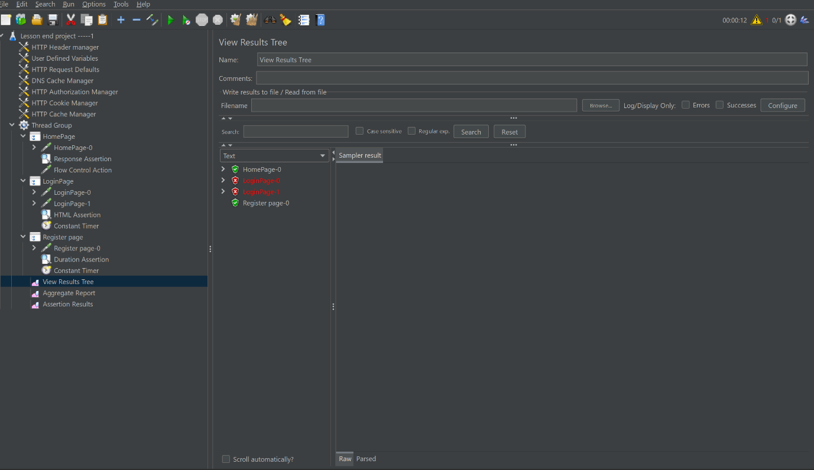

Agreegate Report:

This gives overall report of above scripts

To get Aggregate Report –right click on Thread – Go to Listner-select Aggregate Report

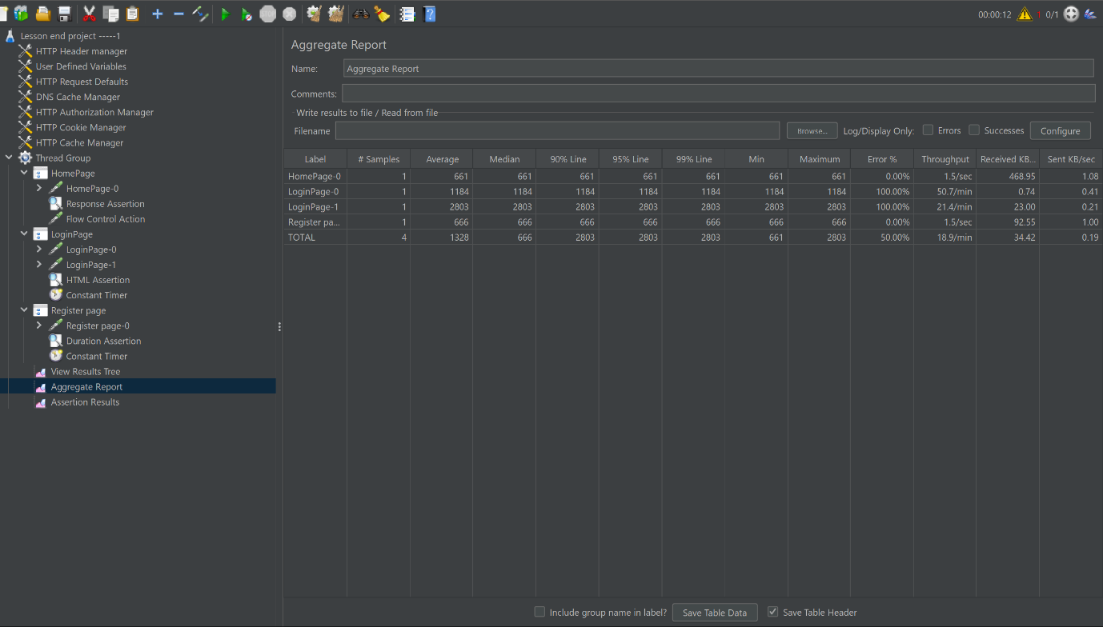

Assertion Results:

Used to check the test scripts whether output is correct or not.

I given Html Assertion that which validates the errors in file and shows the script true or false.

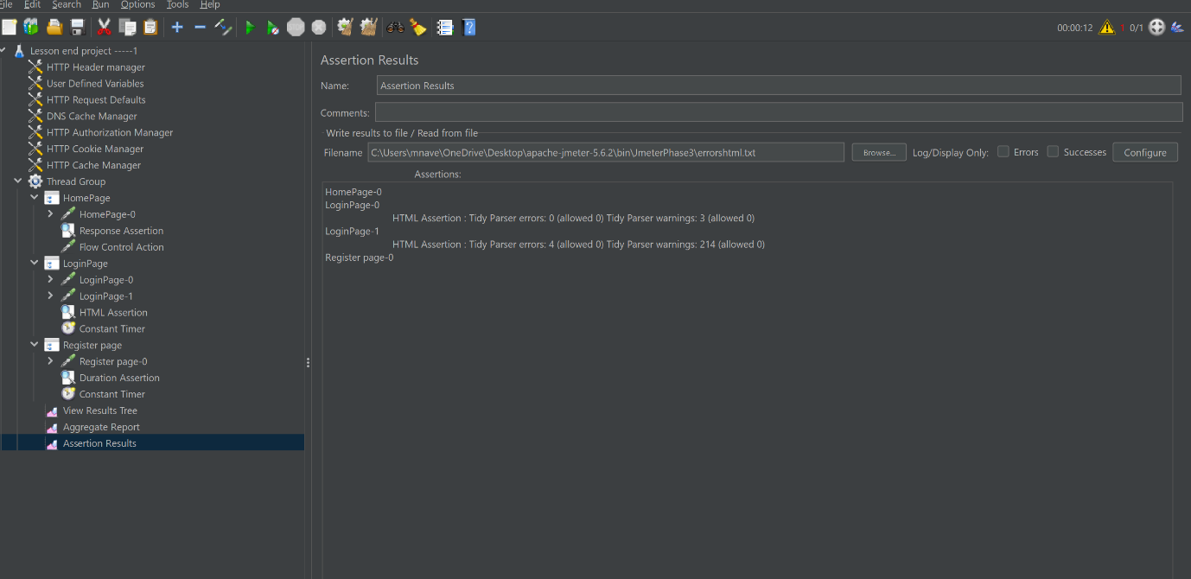

Response Assertion:

We can test this response code or response message or response headers with sampler output test.

If both matches only test script get executes else gives fails.

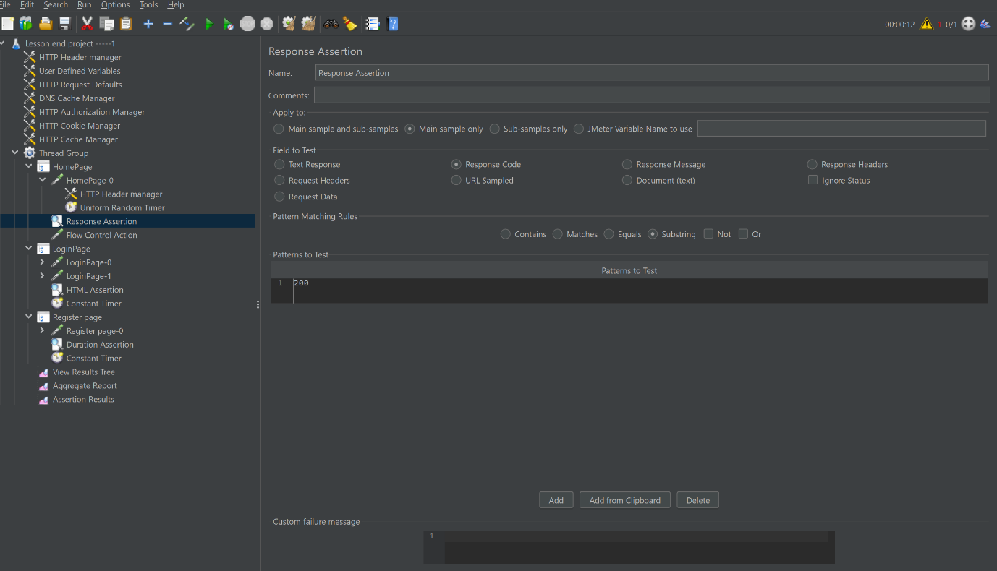

HTML Assertion:

This Captures the errors and warnings and keeps in a separate file .

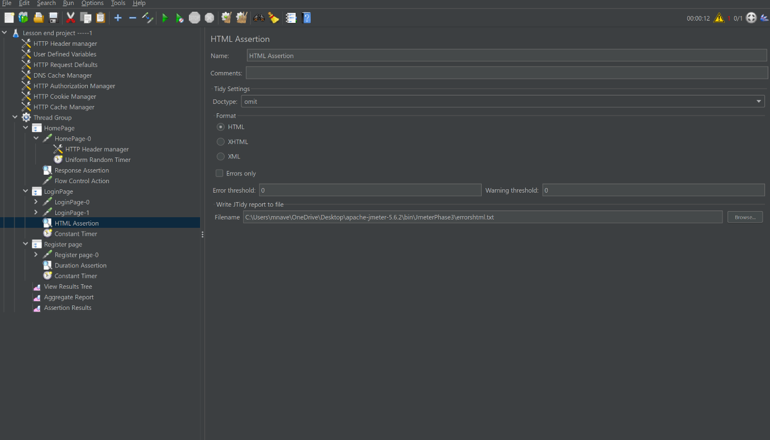

Duration assertion:

It evaluates the script that time takes in milliseconds.

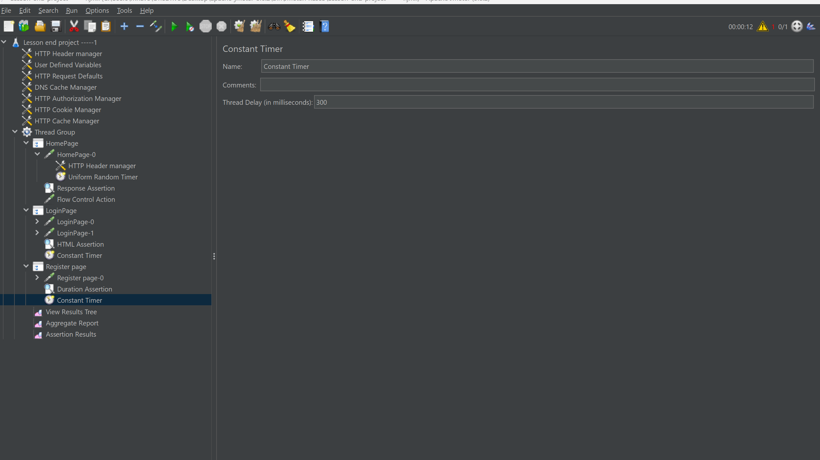

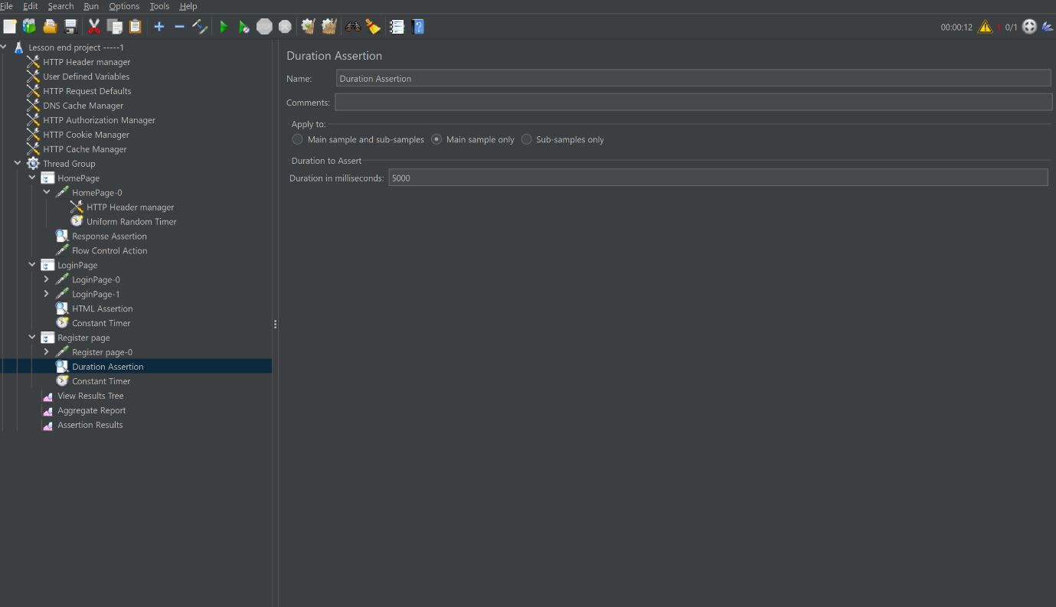

Constant Timer: It gives a Constant wait time for executing request

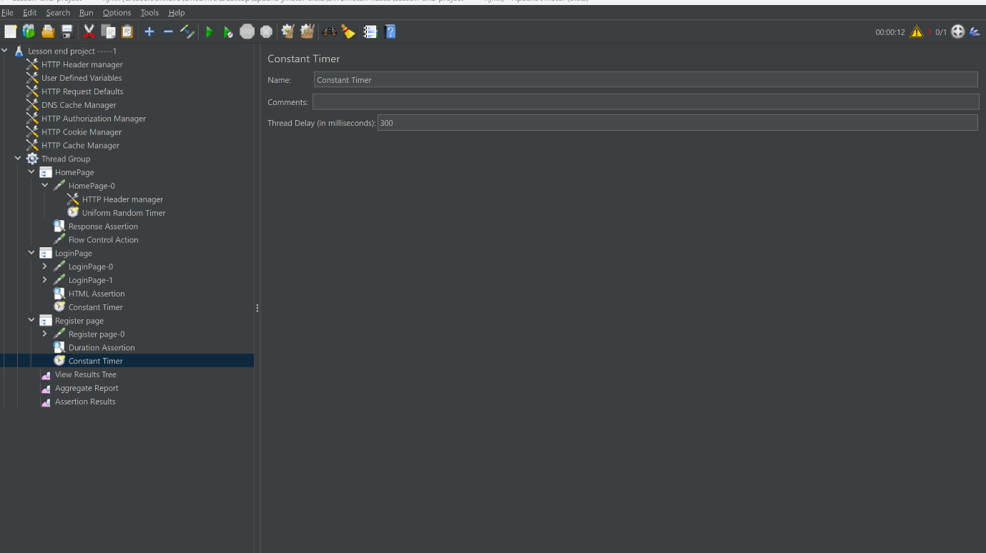

HTML Assertion Errors and Warnings Capture in file:

line 3 column 21 - Warning: <script> lacks "type" attribute

line 8 column 1 - Warning: <html> isn't allowed in <head> elements

line 9 column 5 - Warning: <head> isn't allowed in <body> elements

line 10 column 9 - Warning: <meta> lacks "content" attribute

line 10 column 9 - Warning: <meta> isn't allowed in <body> elements

line 11 column 13 - Warning: <meta> element not empty or not closed

line 11 column 13 - Warning: <meta> isn't allowed in <body> elements

line 12 column 17 - Warning: <meta> element not empty or not closed

line 12 column 17 - Warning: <meta> isn't allowed in <body> elements

line 13 column 21 - Warning: <meta> element not empty or not closed

line 13 column 21 - Warning: <title> isn't allowed in <body> elements

line 13 column 79 - Warning: link isn't allowed in <body> elements

line 14 column 21 - Warning: link isn't allowed in <body> elements

line 15 column 21 - Warning: link isn't allowed in <body> elements

line 16 column 21 - Warning: link isn't allowed in <body> elements

line 17 column 21 - Warning: link isn't allowed in <body> elements

line 26 column 21 - Warning: unknown attribute "crossorigin"

line 26 column 21 - Warning: unknown attribute "async"

line 26 column 21 - Warning: <script> lacks "type" attribute

line 29 column 21 - Warning: unknown attribute "async"

line 29 column 21 - Warning: <script> lacks "type" attribute

line 30 column 21 - Warning: <meta> isn't allowed in <body> elements

line 31 column 21 - Warning: <meta> element not empty or not closed

line 31 column 21 - Warning: <meta> isn't allowed in <body> elements

line 33 column 21 - Warning: <meta> element not empty or not closed

line 36 column 21 - Warning: ID "<script>" uses XML ID syntax

line 39 column 45 - Warning: <script> lacks "type" attribute

line 61 column 21 - Warning: unknown attribute "async"

line 61 column 21 - Warning: <script> lacks "type" attribute

line 62 column 1 - Warning: <script> lacks "type" attribute

line 97 column 36 - Warning: <script> lacks "type" attribute

line 262 column 13 - Warning: </head> isn't allowed in <body> elements

line 263 column 17 - Warning: <body> isn't allowed in <body> elements

line 264 column 21 - Warning: link lacks "type" attribute

line 264 column 21 - Warning: link isn't allowed in <body> elements

line 265 column 1 - Warning: unknown attribute "as"

line 265 column 1 - Warning: link isn't allowed in <body> elements

line 266 column 1 - Warning: <link> isn't allowed in <body> elements

line 267 column 1 - Warning: <link> element not empty or not closed

line 935 column 1 - Warning: unknown attribute "data-backdrop"

line 935 column 1 - Warning: unknown attribute "data-keyboard"

line 935 column 1 - Warning: unknown attribute "aria-hidden"

line 935 column 1 - Warning: unknown attribute "aria-labelledby"

line 935 column 1 - Warning: unknown attribute "role"

line 935 column 1 - Warning: <div> attribute "tabindex" has invalid value "-1"

line 936 column 9 - Warning: unknown attribute "role"

line 938 column 25 - Warning: unknown attribute "role"

line 938 column 25 - Warning: unknown attribute "aria-label"

line 948 column 21 - Warning: trimming empty <div>

line 954 column 41 - Warning: <img> lacks "alt" attribute

line 954 column 129 - Warning: <img> element not empty or not closed

line 955 column 41 - Warning: <br> element not empty or not closed

line 965 column 25 - Warning: unknown attribute "aria-label"

line 967 column 23 - Warning: <img> element not empty or not closed

line 968 column 26 - Warning: unknown attribute "aria-label"

line 970 column 23 - Warning: <img> element not empty or not closed

line 977 column 38 - Warning: trimming empty <h3>

line 982 column 17 - Warning: unknown attribute "aria-label"

line 986 column 67 - Warning: Warning: unescaped & which should be written as &amp;

line 986 column 93 - Warning: Warning: unescaped & which should be written as &amp;

line 986 column 93 - Warning: unknown attribute "aria-label"

line 986 column 107 - Warning: Warning: unescaped & which should be written as &amp;

line 991 column 17 - Warning: <img> element not empty or not closed

line 998 column 9 - Warning: unknown attribute "aria-label"

line 998 column 9 - Warning: unknown attribute "data-dismiss"

line 1,001 column 1 - Warning: <input> isn't allowed in <body> elements

line 1,001 column 1 - Warning: inserting implicit <form>

line 1,002 column 1 - Warning: <input> element not empty or not closed

line 1,004 column 1 - Warning: <input> element not empty or not closed

line 1,004 column 1 - Warning: missing </form> before <div>

line 1,006 column 11 - Error: <header> is not recognized!

line 1,006 column 11 - Warning: discarding unexpected <header>

line 1,007 column 13 - Warning: unknown attribute "aria-atomic"

line 1,007 column 13 - Warning: unknown attribute "role"

line 1,007 column 13 - Warning: unknown attribute "aria-live"

line 1,007 column 13 - Warning: unknown attribute "inert"

line 1,009 column 11 - Warning: discarding unexpected </header>

line 1,011 column 13 - Warning: <img> lacks "alt" attribute

line 1,012 column 13 - Warning: <img> element not empty or not closed

line 1,014 column 18 - Warning: missing </span> before <p>

line 1,015 column 17 - Warning: <br> element not empty or not closed

line 1,018 column 18 - Warning: missing </span> before <div>

line 1,018 column 18 - Warning: trimming empty <span>

line 1,022 column 29 - Warning: <img> element not empty or not closed

line 1,042 column 29 - Warning: <img> element not empty or not closed

line 1,063 column 93 - Warning: <img> lacks "alt" attribute

line 1,063 column 162 - Warning: <img> element not empty or not closed

line 1,063 column 541 - Warning: <img> element not empty or not closed

line 1,063 column 683 - Warning: <img> element not empty or not closed

line 1,063 column 822 - Warning: <img> element not empty or not closed

line 1,063 column 986 - Warning: <img> element not empty or not closed

line 1,064 column 93 - Warning: trimming empty <div>

line 1,064 column 105 - Warning: trimming empty <span>

line 1,064 column 112 - Warning: trimming empty <div>

line 1,064 column 118 - Warning: trimming empty <div>

line 1,067 column 25 - Error: <section> is not recognized!

line 1,067 column 25 - Warning: discarding unexpected <section>

line 1,068 column 29 - Warning: unknown attribute "data-ride"

line 1,070 column 33 - Warning: unknown attribute "role"

line 1,072 column 66 - Warning: <br> element not empty or not closed

line 1,074 column 33 - Warning: <img> element not empty or not closed

line 1,077 column 59 - Warning: <br> element not empty or not closed

line 1,079 column 33 - Warning: <img> element not empty or not closed

line 1,082 column 60 - Warning: <br> element not empty or not closed

line 1,084 column 33 - Warning: <img> element not empty or not closed

line 1,085 column 55 - Warning: trimming empty <div>

line 1,088 column 41 - Warning: unknown attribute "data-slide-to"

line 1,088 column 41 - Warning: unknown attribute "data-target"

line 1,088 column 100 - Warning: trimming empty <li>

line 1,089 column 41 - Warning: unknown attribute "data-slide-to"

line 1,089 column 41 - Warning: unknown attribute "data-target"

line 1,089 column 85 - Warning: trimming empty <li>

line 1,090 column 41 - Warning: unknown attribute "data-slide-to"

line 1,090 column 41 - Warning: unknown attribute "data-target"

line 1,090 column 85 - Warning: trimming empty <li>

line 1,091 column 33 - Warning: trimming empty <ol>

line 1,092 column 55 - Warning: trimming empty <div>

line 1,099 column 21 - Warning: discarding unexpected </section>

line 1,110 column 58 - Warning: <img> element not empty or not closed

line 1,116 column 5 - Warning: unknown attribute "novalidate"

line 1,121 column 13 - Warning: unknown attribute "required"

line 1,121 column 13 - Warning: unknown attribute "autocomplete"

line 1,121 column 13 - Warning: unknown attribute "placeholder"

line 1,125 column 13 - Warning: unknown attribute "required/"

line 1,125 column 13 - Warning: unknown attribute "autocomplete"

line 1,125 column 13 - Warning: unknown attribute "placeholder"

line 1,126 column 13 - Warning: <input> element not empty or not closed

line 1,127 column 14 - Warning: missing </span> before <div>

line 1,139 column 20 - Warning: trimming empty <i>

line 1,141 column 9 - Warning: discarding unexpected </span>

line 1,151 column 44 - Warning: unknown attribute "data-eventd"

line 1,151 column 44 - Warning: unknown attribute "data-event"

line 1,156 column 17 - Warning: unknown attribute "data-clickedtype"

line 1,156 column 17 - Warning: unknown attribute "data-eventd"

line 1,156 column 17 - Warning: unknown attribute "data-event"

line 1,170 column 22 - Warning: unknown attribute "data-clickedtype"

line 1,170 column 22 - Warning: unknown attribute "data-eventd"

line 1,170 column 22 - Warning: unknown attribute "data-event"

line 1,171 column 18 - Warning: missing </button> before <div>

line 1,171 column 42 - Warning: inserting implicit <button>

line 1,172 column 17 - Warning: inserting implicit <button>

line 1,177 column 10 - Warning: unknown attribute "role"

line 1,177 column 10 - Warning: <div> attribute "tabindex" has invalid value "-1"

line 1,177 column 10 - Warning: unknown attribute "data-keyboard"

line 1,177 column 10 - Warning: unknown attribute "data-backdrop"

line 1,180 column 17 - Warning: unknown attribute "data-dismiss"

line 1,184 column 60 - Warning: trimming empty <p>

line 1,185 column 17 - Warning: trimming empty <div>

line 1,188 column 25 - Warning: unknown attribute "data-dismiss"

line 1,211 column 10 - Warning: input Anchor "referer" already defined

line 1,213 column 14 - Warning: unknown attribute "data-clickedtype"

line 1,213 column 14 - Warning: unknown attribute "data-eventd"

line 1,213 column 14 - Warning: unknown attribute "data-event"

line 1,214 column 18 - Warning: missing </button> before <div>

line 1,214 column 18 - Warning: trimming empty <button>

line 1,214 column 42 - Warning: inserting implicit <button>

line 1,214 column 38 - Warning: trimming empty <button>

line 1,214 column 38 - Warning: trimming empty <div>

line 1,215 column 17 - Warning: inserting implicit <button>

line 1,220 column 10 - Warning: unknown attribute "role"

line 1,220 column 10 - Warning: <div> attribute "tabindex" has invalid value "-1"

line 1,220 column 10 - Warning: unknown attribute "data-keyboard"

line 1,220 column 10 - Warning: unknown attribute "data-backdrop"

line 1,220 column 10 - Warning: <div> Anchor "showEnableCookies" already defined

line 1,223 column 17 - Warning: unknown attribute "data-dismiss"

line 1,227 column 60 - Warning: trimming empty <p>

line 1,228 column 17 - Warning: trimming empty <div>

line 1,231 column 25 - Warning: unknown attribute "data-dismiss"

line 1,254 column 10 - Warning: input Anchor "referer" already defined

line 1,255 column 22 - Warning: unknown attribute "data-clickedtype"

line 1,255 column 22 - Warning: unknown attribute "data-eventd"

line 1,255 column 22 - Warning: unknown attribute "data-event"

line 1,256 column 18 - Warning: missing </button> before <div>

line 1,256 column 18 - Warning: trimming empty <button>

line 1,256 column 42 - Warning: inserting implicit <button>

line 1,256 column 38 - Warning: trimming empty <button>

line 1,256 column 38 - Warning: trimming empty <div>

line 1,257 column 17 - Warning: inserting implicit <button>

line 1,262 column 10 - Warning: unknown attribute "role"

line 1,262 column 10 - Warning: <div> attribute "tabindex" has invalid value "-1"

line 1,262 column 10 - Warning: unknown attribute "data-keyboard"

line 1,262 column 10 - Warning: unknown attribute "data-backdrop"

line 1,262 column 10 - Warning: <div> Anchor "showEnableCookies" already defined

line 1,265 column 17 - Warning: unknown attribute "data-dismiss"

line 1,269 column 60 - Warning: trimming empty <p>

line 1,270 column 17 - Warning: trimming empty <div>

line 1,273 column 25 - Warning: unknown attribute "data-dismiss"

line 1,296 column 10 - Warning: input Anchor "referer" already defined

line 1,297 column 22 - Warning: unknown attribute "data-clickedtype"

line 1,297 column 22 - Warning: unknown attribute "data-type"

line 1,297 column 22 - Warning: unknown attribute "data-border"

line 1,297 column 22 - Warning: unknown attribute "data-color"

line 1,298 column 13 - Warning: unknown attribute "data-clickedtype"

line 1,298 column 13 - Warning: unknown attribute "data-eventd"

line 1,298 column 13 - Warning: unknown attribute "data-event"

line 1,298 column 13 - Warning: <button> attribute "id" lacks value

line 1,299 column 18 - Warning: missing </button> before <div>

line 1,299 column 42 - Warning: inserting implicit <button>

line 1,300 column 17 - Warning: inserting implicit <button>

line 1,305 column 10 - Warning: unknown attribute "role"

line 1,305 column 10 - Warning: <div> attribute "tabindex" has invalid value "-1"

line 1,305 column 10 - Warning: unknown attribute "data-keyboard"

line 1,305 column 10 - Warning: unknown attribute "data-backdrop"

line 1,305 column 10 - Warning: <div> Anchor "showEnableCookies" already defined

line 1,308 column 17 - Warning: unknown attribute "data-dismiss"

line 1,312 column 60 - Warning: trimming empty <p>

line 1,313 column 17 - Warning: trimming empty <div>

line 1,316 column 25 - Warning: unknown attribute "data-dismiss"

line 1,336 column 65 - Warning: unknown attribute "data-eventd"

line 1,336 column 65 - Warning: unknown attribute "data-event"

line 1,340 column 1 - Warning: <script> lacks "type" attribute

line 1,451 column 2 - Warning: <p> attribute "id" has invalid value "3rd_party_cookie_test_results"

line 1,451 column 35 - Warning: replacing element <p> by <br>

line 1,500 column 1 - Warning: <br> element not empty or not closed

line 1,501 column 1 - Warning: <br> element not empty or not closed

line 1,506 column 103 - Warning: missing </div>

InputStream: Doctype given is ""

InputStream: Document content looks like XHTML 1.0 Transitional

214 warnings, 4 errors were found!

This document has errors that must be fixed before

using HTML Tidy to generate a tidied up version.

The alt attribute should be used to give a short description

of an image; longer descriptions should be given with the

longdesc attribute which takes a URL linked to the description.

These measures are needed for people using non-graphical browsers.

For further advice on how to make your pages accessible

see "http://www.w3.org/WAI/GL". You may also want to try

"http://www.cast.org/bobby/" which is a free Web-based

service for checking URLs for accessibility.

1698827016503,661,HomePage-0,200,OK,Thread Group 1-1,text,true,,317412,734,1,1,https://www.simplilearn.com/,187,0,109

1698827016503,187,HomePage-0-0,301,Moved Permanently,Thread Group 1-1,text,true,,689,365,1,1,http://simplilearn.com/,187,0,109

1698827016691,473,HomePage-0-1,200,OK,Thread Group 1-1,text,true,,316723,369,1,1,https://www.simplilearn.com/,255,0,181

1698827018000,1184,LoginPage-0,200,OK,Thread Group 1-1,text,false,Tidy Parser errors: 0 (allowed 0) Tidy Parser warnings: 3 (allowed 0),892,500,1,1,https://lms.simplilearn.com/,1184,0,882

1698827021145,2803,LoginPage-1,200,OK,Thread Group 1-1,text,false,Tidy Parser errors: 4 (allowed 0) Tidy Parser warnings: 214 (allowed 0),66004,611,1,1,https://accounts.simplilearn.com/user/login?redirect_url=https%3A%2F%2Flms.simplilearn.com%2F,2519,0,1045

1698827028531,666,Register page-0,200,OK,Thread Group 1-1,text,true,,63117,679,1,1,https://accounts.simplilearn.com/user/register?redirect_url=https%3A%2F%2Flms.simplilearn.com%2F,413,0,0